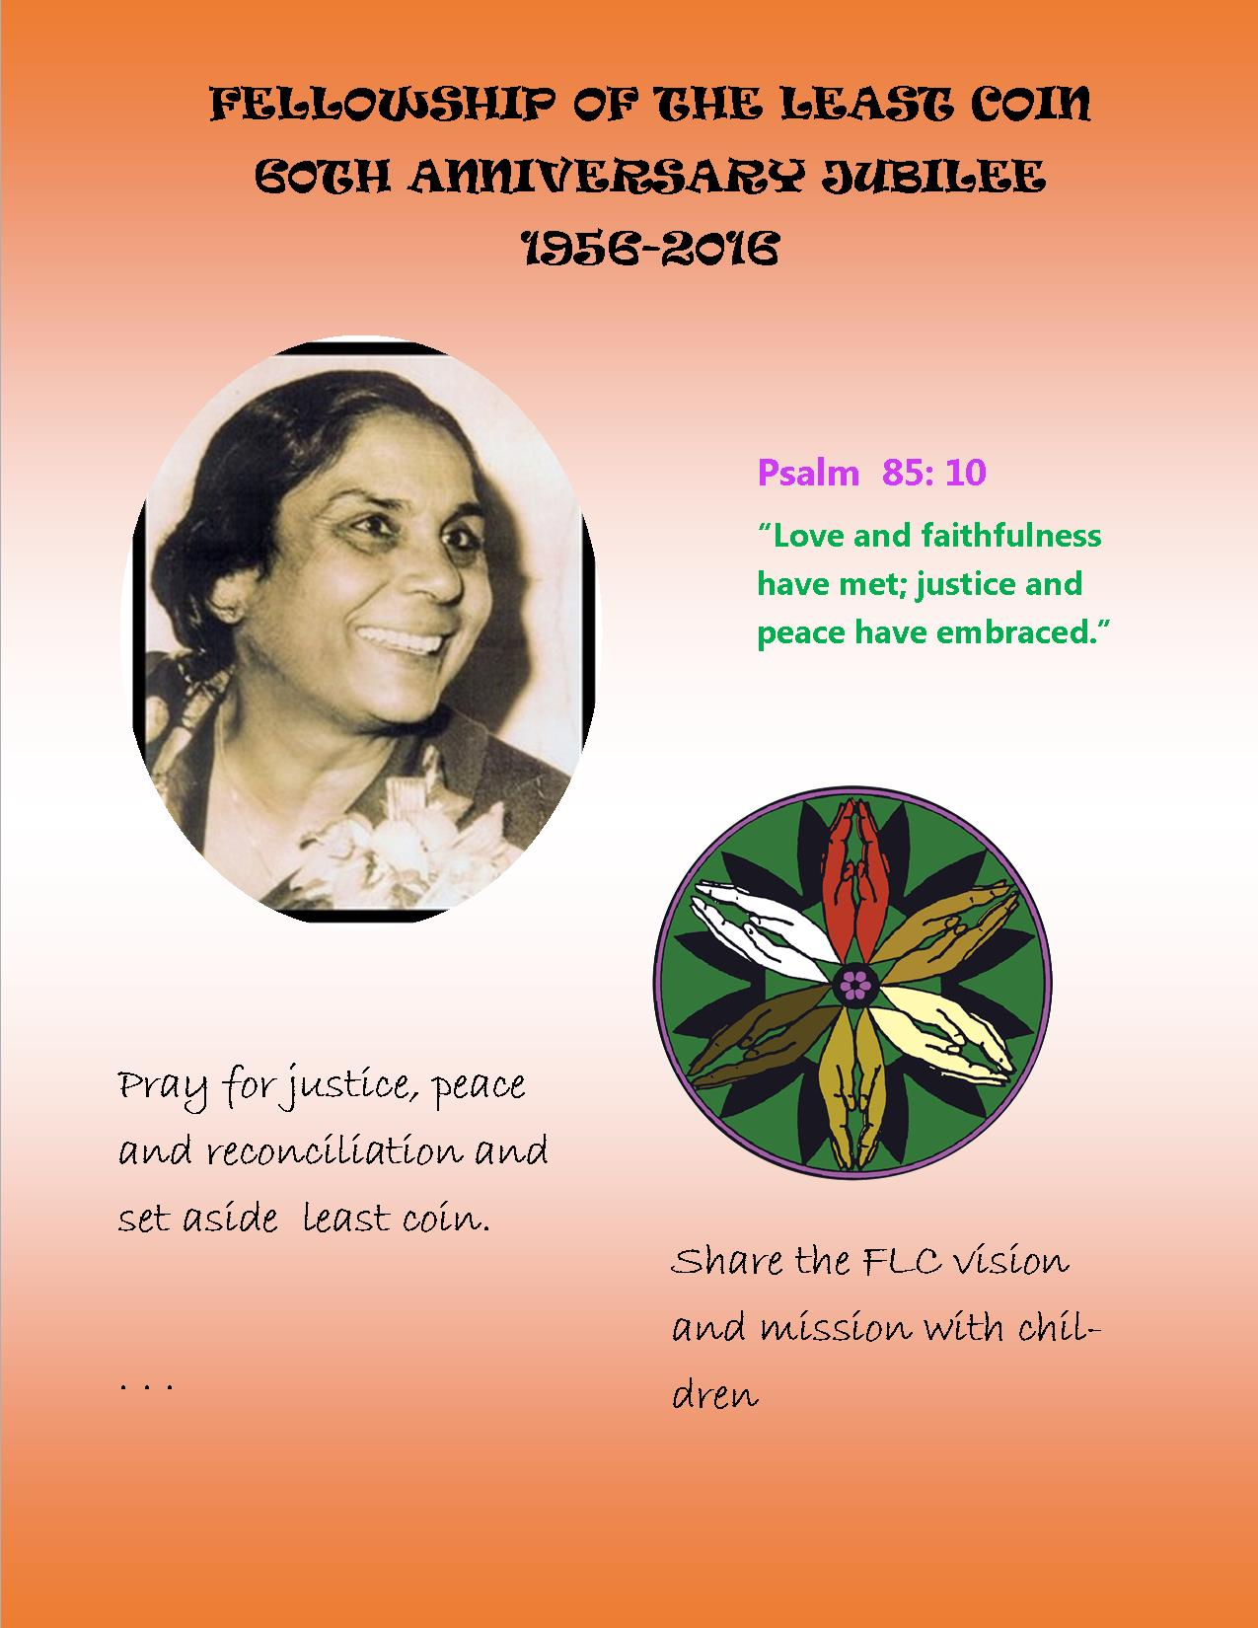

A Song to Celebrate the
Fellowship of the Least Coin and
its Founder,
Shanti Solomon
Verse 1.
As I was walking down the street,
I saw a penny at my feet;
I picked it up, but could not see
How it was any use to me.
Chorus (repeat between each verse)
Round and round your Least Coin goes;
Love and prayer for all it shows!

Verse 2.
“Don’t be so sure!” a small voice said—
A bird was sitting on my head—
“What Shanti started long ago
Has never stopped to grow and grow.”
Round and round your Least Coin goes;
Love and prayer for all it shows!

Verse 3.
“On every continent today,
Whenever Christian women pray,
They always give their pennies, too,
The way that Shanti said to do.”
Round and round your Least Coin goes;
Love and prayer for all it shows!

Verse 4.
As, one by one, the pennies mount,
What they achieve can really count!
“In Thailand, you should really know it,
Kids eat fresh food and help mom grow it!”
Round and round your Least Coin goes;
Love and prayer for all it shows!

Verse 5.
“In Togo, ladies manage money
To sell their handmade pots, or honey;
They celebrate with dance and song—
They never fear they’ll count change wrong!”
Round and round your Least Coin goes;
Love and prayer for all it shows!

Verse 6.
In Guatemala, I’ve been told
Shy Mayan women now are bold
To teach and preach and spread God’s word—
Or that’s the story I have heard!”
Round and round your Least Coin goes;
Love and prayer for all it shows!

Verse 7.
“So when you love and when you pray
For needy families far away,
Your Least Coin gift shows how you care,
And brings a smile both here and there!”
Round and round your Least Coin goes;
Love and prayer for all it shows!
Verse 8.
The bird flew off and home I ran;
To save my pennies is my plan
But, even more, to work and pray
To build a peaceful world today.
Round and round your Least Coin goes
Love and prayer for all it shows!

